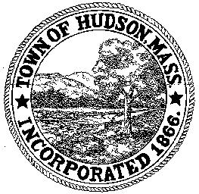

BOARD OF HEALTH
78 Main Street
Hudson, MA 01749
(978) 562-2020
Meeting Minutes
August 30, 2017
5:30 PM

Venue: Town Hall (78 Main Street, Hudson, MA 01749)
3rd Floor Conference Room B

- Preliminaries
1.1 Call to Order
Meeting was called to order by Mr. Murphy at 5:30 pm

1.2 Roll Call
Mr. Jay Murphy (Chairman)
Ms. Christie Vaillancourt (Vice Chairwoman)
Mr. Michael Delfino (Clerk)

Staff
Ms. Alexandra DePalo (Interim Director)

2.0 General Business
2.1 Vouchers
Mr. Delfino motioned to approve the vouchers as presented. The motion was seconded by Mr. Murphy, and passed unanimously.

2.2 Minutes July 26, 2017
Mr. Delfino motioned to approve the July 26, 2017 meeting minutes. The motion was seconded by Ms. Vaillancourt, and passed unanimously.

3.0 New Business
3.1 Discussion of Health Director interviews
To date, 4 applications have been received. A fifth may have been received prior to our meeting. Board members and Alex will submit a panel of questions (by e-mail to dcraig@townofhudson.org) and determine which questions to put forward and who will ask. Dr. Wong has offered to help review the applications and offer his input. The Board would like to interview up to 5 applicants on September 12 and September 14 beginning at 5:30PM. Final interviews with top 2 candidates will meet with the Board, Alex and Mr. Tom Moses either September 19 or 20 or September 26 or September 27

3.2 Updates from Interim Director

Ms. DePalo met with Elliott Brown who is the Tobacco Compliance Officer for our region.

The YSAP Coordinator will be out on leave until the end of September. Alex has notified the State.

Mr. Delfino asked about the current status of the Transfer Station is. He understood BP is interested in signing a 10-15 year Town contract. BP will pay for the project. Alex will talk to Dr. Wong about the latest status.

4.0 Adjournment
Mr. Murphy motioned to adjourn the meeting at 6:20PM. The motion was seconded by Ms. Vaillancourt, and passed unanimously.

Next meeting of the Board will be held on September 27, 2017 at 5:30 pm.

